3.1>>ODD OR EVEN
echo "ODD OR EVEN"
echo -n "Enter 'n' >> "
read n
if [ $((n%2)) -eq 0 ]; then
echo "$n is EVEN"
else
echo "$n is ODD"
fi

OUTPUT
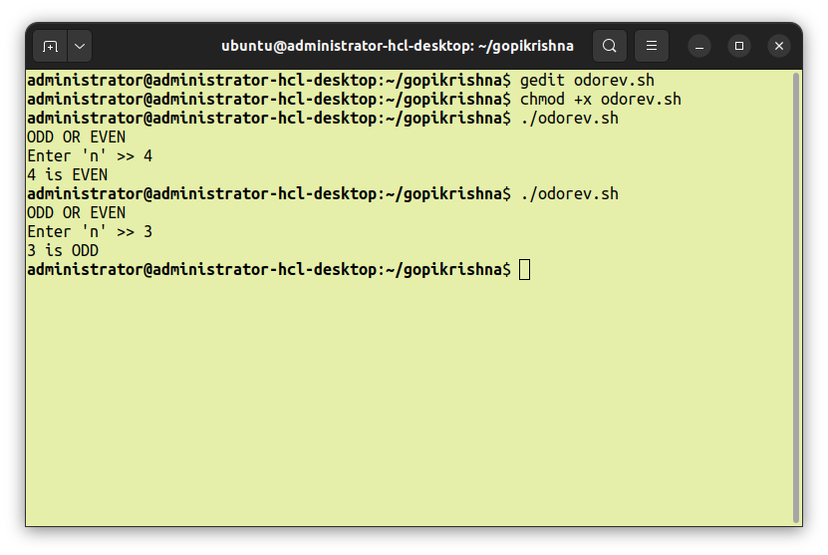

3.2>>FACTORIAL OF A NUMBER
echo "FACTORIAL OF 'n'"
echo -n "Enter 'n' >> "
read n
fact=1
z=0
if [ $n == $z ] ; then
echo "FACTORIAL OF 0 >> 1"
else
for((i=2;i<=n;i++))
do
fact=$((fact*i))
done
fi
echo -n "FACTORIAL OF '$n' >> $fact"
echo

OUTPUT
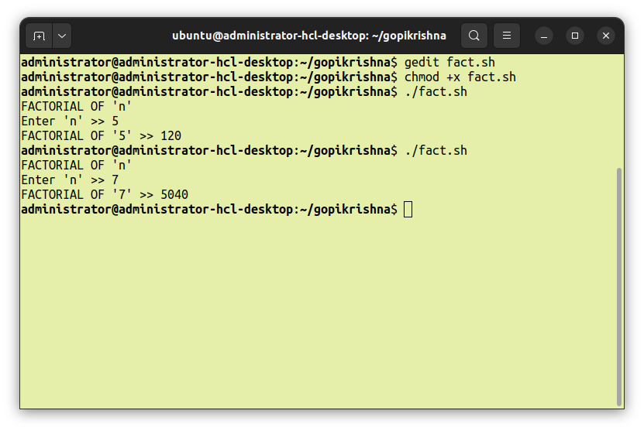
3.3>>FIBONACCI SERIES
echo "FIBONACCI SERIES"
n1=0
n2=1
n3=$((n1+n2))
echo -n "Enter Limit >> "
read lim
echo -n "FIBONACCI SERIES upto $lim >> "
echo -n "$n1 $n2"
for (( i=3 ; i <= lim ; ++i ))
do
echo -n " $n3"
n1=$n2
n2=$n3
n3=$((n1+n2))
done
echo
OUTPUT
